ENTERING RECURRING ENTRIES

You can store your payroll entry in the general ledger recurring entry screen. (GU3)

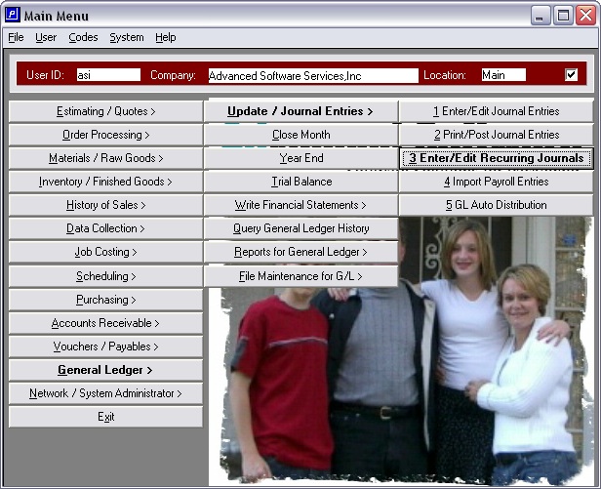

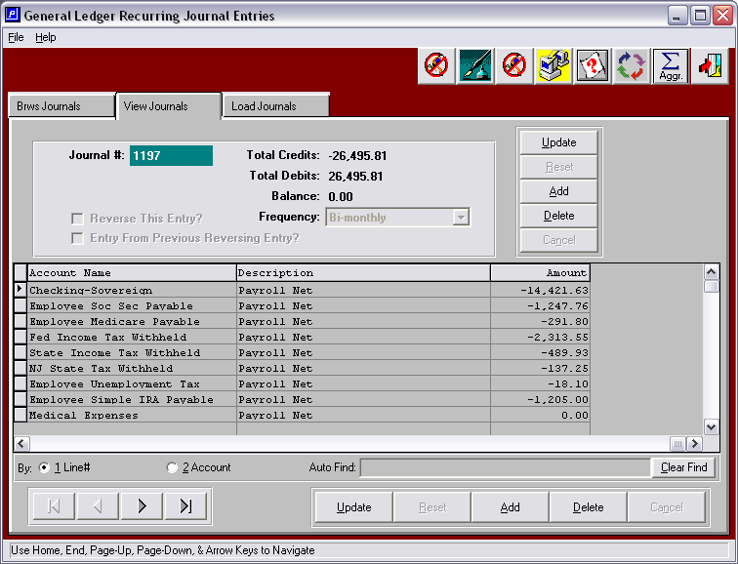

Enter each line and the account number the amount pertains to, as above. Make sure to enter negative in front if amount is a credit. Once you are done entering your payroll entry save it. You can then load your journal whenever you need to post payroll by going to the load journal tab.

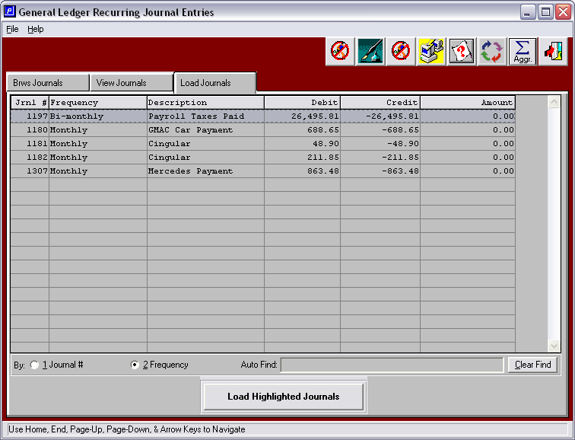

The entry will then move into the GU1 Enter/Edit journal entries so that you can modify the entry, give it the right date and then post.

